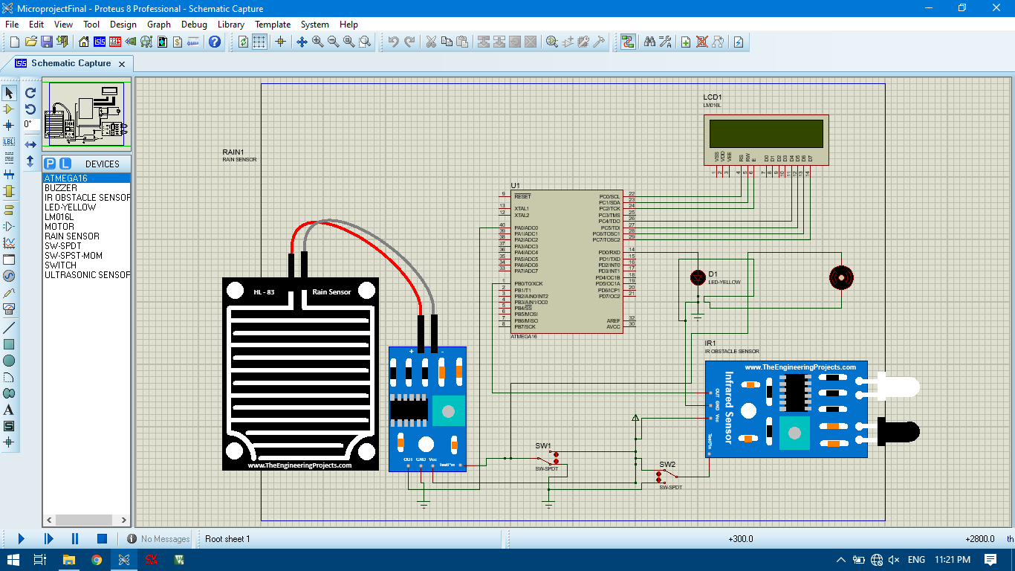**Automatic Viper and Alert System**

**Proteus Simulation**